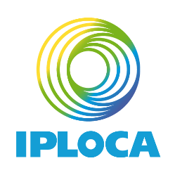

APPLICATION FOR CANDIDATURE
AS
2024-2025 IPLOCA BOARD MEMBER

If you wish to run for a vacant seat, please complete this form and send it to Georges Hage, IPLOCA Executive Secretary, georges.hage@iploca.com with your brief résumé and a head and shoulder photograph before the deadline, 12 August 2024.
Elections will take place at the Election Meetings held during the 2024 Annual Convention in Sorrento, Italy.
NOTE: The language of the Association is English (By-laws, clause 17). Proficiency in spoken and written English is a requirement for all candidates to be considered.

- Name and Title ____________________________________________________

- Company Name _____________________________________________________

- Representing

□ Regular Members

__________________________________________(Geographic Region)

Or

□ Associate Members

__________________________________________(Geographic Region)

- Why are you interested in serving on the Board? (If you require more space, attach a separate sheet of paper)

- What contribution do you believe you can make towards helping IPLOCA achieve its objectives listed in the By-laws?

- If you would like to achieve one goal during your term of office, what would it be?

- What other volunteer commitments do you currently have?

I have read and agree to the responsibilities and requirements of being an IPLOCA Board Director.

Signature __________________________________________ Date______________________

My application is supported by the following senior management representative in my company.

_______________________________________________________________________________

Return this completed form along with your brief résumé and a photograph as soon as possible to Georges Hage, IPLOCA Executive Secretary, georges.hage@iploca.com

